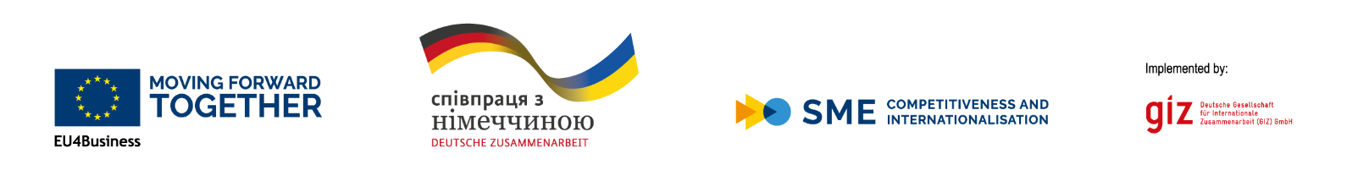

Clarification on submitting a grant application within the framework of the "EU4Business: competitiveness and internationalization of SMEs" programme
Small projects competition, December 2022

The international technical assistance programme “EU4Business: SME Competitiveness and Internationalisation”, that is co-financed by the European Union and the German Government and is implemented by the German Federal Company “Deutsche Gesellschaft für Internationale Zusammenarbeit (GIZ) GmbH”. The programme aims to create better conditions for the development of Ukrainian small and medium-sized enterprises, support innovation and export promotion, resulting in sustainable and equitable economic growth.

EU4Business is an umbrella initiative that includes all EU support to small and medium-sized businesses (SMEs) in the Eastern Partnership countries. Read more: www.eu4business.org.ua

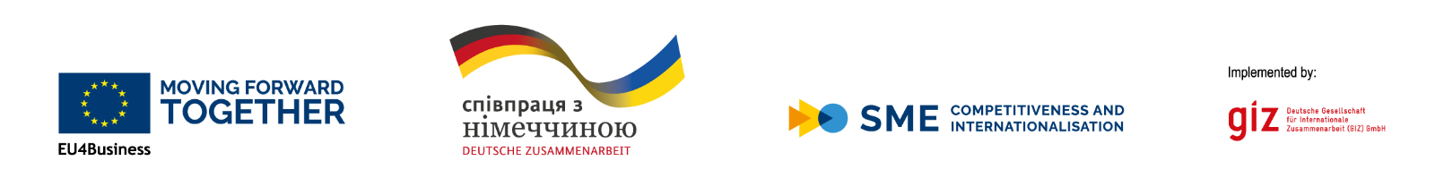
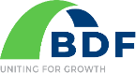

Dear partners!
We thank you for your interest in participating in the competition for financial assistance announced by the "EU4Business: Competitiveness and Internationalization of SMEs" programme, that is co-financed by the European Union and the German Government.
The programme is implemented by the German Federal Company “Deutsche Gesellschaft für Internationale Zusammenarbeit (GIZ) GmbH”. Within the framework of the programme, regional and sectoral measures of educational and consulting support for small and medium-sized enterprises are provided for increasing their innovative capacity and implementing their own investment ideas. The program also includes support for the development of industrial clusters throughout Ukraine.
One of the tools of the program "EU4Business: competitiveness and internationalization of SMEs" is the provision of financial assistance (grants) to Ukrainian clusters selected in the process of an open competition.
The intended grants are intended to contribute to the formation, development and strengthening of clusters and thereby contribute to the development of small and medium-sized businesses, as well as the development of entrepreneurship culture and competencies, to expand the access of SMEs to markets, including international ones, to support innovation and digitalization of internal and external processes, cooperation with various scientific and educational institutions, etc.
This competition is open and is conducted in accordance with EU and GIZ regulations, which guarantee an objective and independent evaluation of applications.
We hope that the following clarifications will help you to make your application interesting and competitive.

The GIZ team wishes you success and thanks you for your cooperation!

I. General and special information:
The goal of the small-projects competition - is to support interested clusters of Ukraine in the implementation of programs/projects/actions aimed at supporting the development and strengthening of cluster’s itself, stimulating the development of small and medium-sized businesses, with a special emphasis on promoting exports, stimulating innovation and digitalization, improving public-private dialogue, technology transfer, as well as attracting state and foreign investments.
The main thematic areas of the projects: the development of clusters as institutions, including measures aimed at supporting business sustainability in wartime, promoting exports, promoting innovation and digitalization, improving public-private partnerships, technology transfer, attracting public and foreign investments to invest in local SMEs in order to improve their innovation and export potential.
Compliance with current strategies/plans: projects proposed for the grant competition must comply with current strategies/plans for the development of clusters and clearly demonstrate a lasting and effective impact on strengthening the cluster and its members (SMEs).
Equal opportunities for receiving services and environmental aspects: the project proposal must guarantee equal opportunities of access to services/services of the cluster and SMEs (for example, access for companies headed or owned by women), as well as those that care about environmental protection in their activities.
Target audience: legally registered and actively operating clusters on the territory of Ukraine, which must demonstrate active economic activity and potential for the development of both the cluster itself and its members (SMEs), have active strategies/plans for the maintenance and development of the cluster/SME.
II. Main evaluation criteria:
• Compliance with the priorities of the international support program "EU4Business: competitiveness and internationalization of SMEs" regarding the support of SMEs through cluster associations (development of entrepreneurial culture and knowledge, including measures aimed at supporting the sustainability of business in wartime; expanding access of SMEs to markets, including international ones; maintaining innovations in the SME sector, etc.
• Quantitative and qualitative indicators for planned activities;
• Clear and realistic outcomes (e.g. benefits for SMEs, job creation, income generation, etc.);
• Equal access to services;
• Viability and continuation of funding after end of grant support;
• Bottom-up approach, taking into account the opinion and business needs in the application;
• Willingness to share the acquired best practices regarding the development of clusters and the provision of support to SMEs;
Such criteria will be considered as additional advantages:
• Potential for reproducing the project in other clusters;
• Partnership for the implementation of measures with at least one cluster from an EU member state;
• Partnership for project implementation with at least one business support organization (e.g business associations, development agencies, etc.).

III. Estimated schedule:
• Start of the competition and distribution of information about the competition – December 2022;
• Training webinar for interested clusters - January 2023. Interested persons can register for the webinar by sending a short message to: eu4business.ukraine@giz.de
no later than 14.00, 16.01.2023. The letter must include: the name/surname of the participant(s), his/her position, the name of the organization, and the e-mail address where the link to the webinar should be sent.
• Application deadline: – until 12:00 on January 27, 2023; Applications must be submitted in Ukrainian and English (translation) in Word format (without signature), as well as in Ukrainian in pdf format together with a short cover letter in Ukrainian or English to the address: mail@bdf.gov.ua

• Receipt of the application will be confirmed by e-mail within max. 48 hours

• Evaluation of project proposals: until February 15, 2023;

• Announcement of results - February 20, 2023; the results of the competition will be announced on the EU4business program page on Facebook, and the winners will be notified by official letters.

• Webinar-instruction on project reporting on signing contracts with winners: February 2023;

• Start of implementation of small projects: March 2023;

• Completion of projects: December 2023;

IV. Other conditions:
• Maximum amount of the grant: EUR 25 000 in hryvnia equivalent at the official exchange rate of the National Bank of Ukraine;

• Estimated number of grants within the competition: up to 8;

• Geographic coverage: Any Ukrainian city, except temporarily occupied territories of Ukraine and Crimea;

• Exclusion from participation in the contest: Applications that will be sent after the announced deadline (12:00, January 27, 2023) or/and those that significantly deviate from the subject matter and rules of the contest set forth in this Explanation, as well as those applications, which are sent with an incomplete package of additional documents, will not be evaluated;

• Warning: In the event that two or more applicants submit proposals with similar ideas, the project with the best ratio of price and quality of activities will be preferred.

